1 get: https://parallelum.com.br/fipe/api/v1/carros/marcas

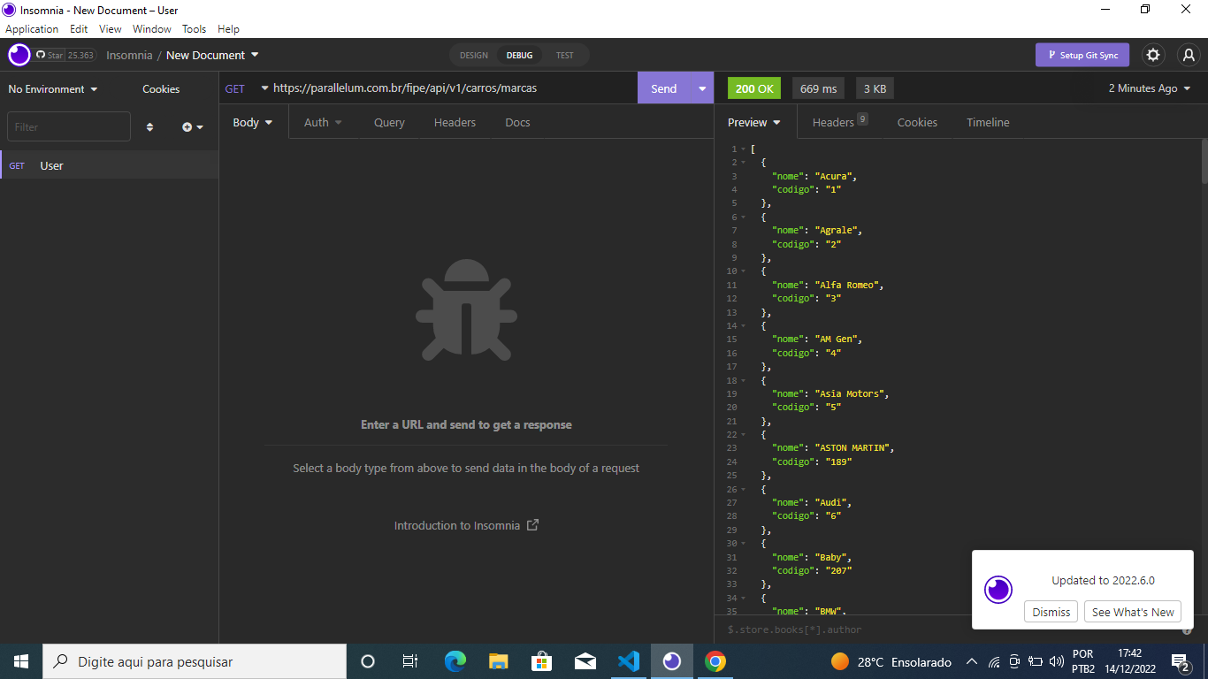

2 get: <https://parallelum.com.br/fipe/api/v1/carros/marcas/189/modelos>

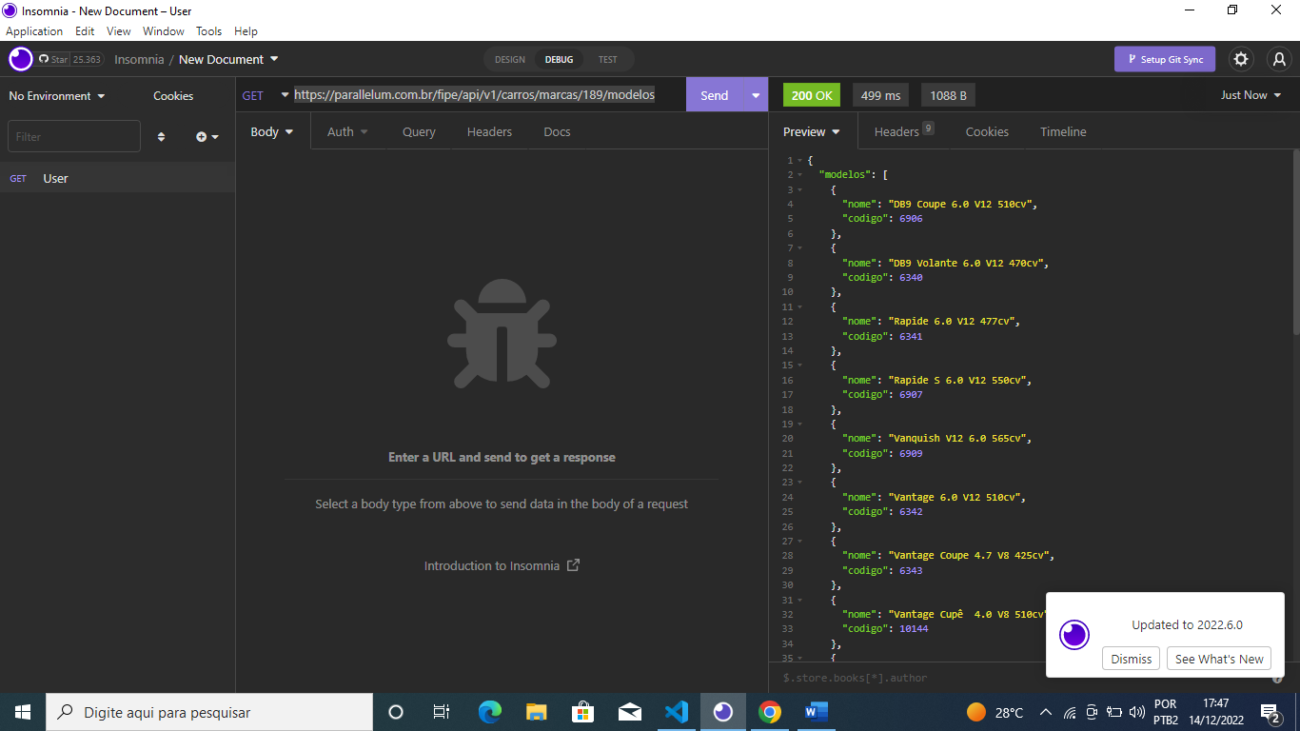

3 get: <https://parallelum.com.br/fipe/api/v1/carros/marcas/189/modelos/10144/anos>

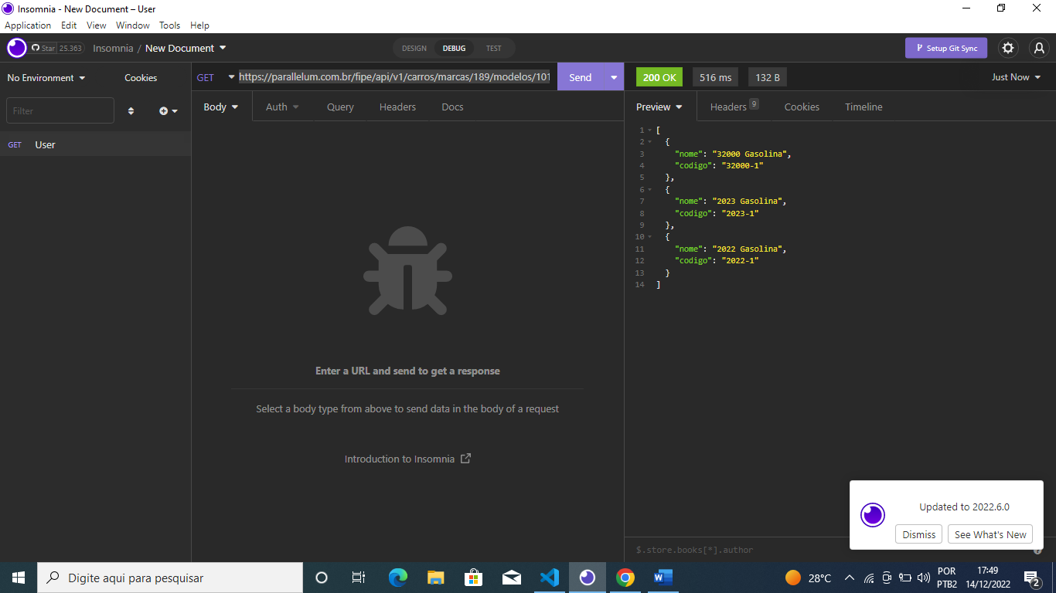

4 get: <https://parallelum.com.br/fipe/api/v1/carros/marcas/189/modelos/10144/anos/2023-1>

